WEEK 6 ASSIGNMENT

1,Find the shortest path form node 1 to all other nodes using Djikstra's algorithm.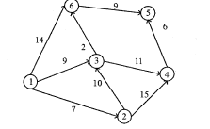

2.Explain in detail working of OSPF routing protocol with neat diagram

3.Explain the distance vector routing algorithm with an example.

4.How the link state routing algorithm creates routing table for node A in the given network

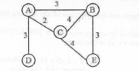

5.Explain RIP protocol message types and its timers.